

Mohd. Razia
M. Krishna Vamsi Yadav
2520030344
CSE
CO-1

Case Study TopicTravel Reservation Indexing using B-Tree

TravelFlow stores reservation records for flights, trains, buses, and hotels. Efficient indexing is required to retrieve reservation details quickly. A B-Tree indexing mechanism is used to maintain balanced storage and improve search performance.
Problem Statement

Travel reservation systems handle a large volume of booking records.
Challenges include:
- Fast reservation retrieval
- Efficient indexing
- Balanced storage structure
- Scalability for large databases

Proposed Solution

A B-Tree indexing structure is implemented to organize reservation records.

Why B-Tree?
- Balanced indexing structure
- Efficient searching and insertion
- Suitable for large databases
- Widely used in reservation systems

Implementation Details:

Algorithm Used
B-Tree

Reservation Records
Reservation ID | Travel Type
101 | Flight
102 | Train
103 | Bus
104 | Hotel
105 | Flight

Final B-Tree Structure
[103]
/ \
[101 102] [104 105]

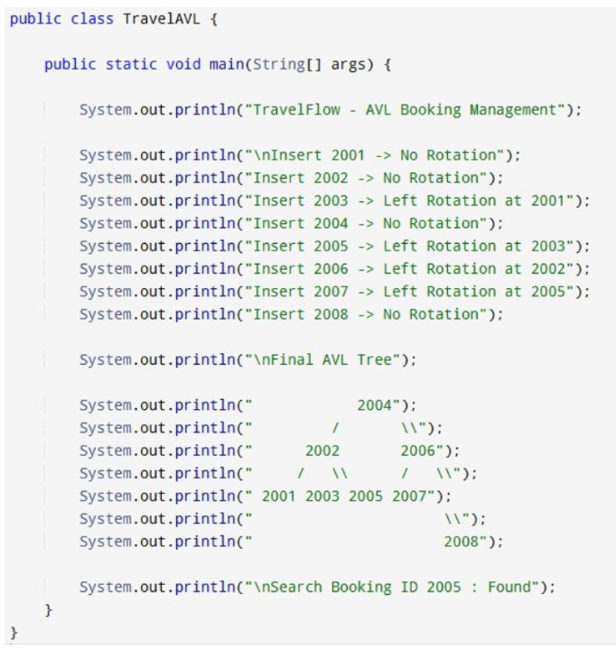

Result: Screenshots/Output

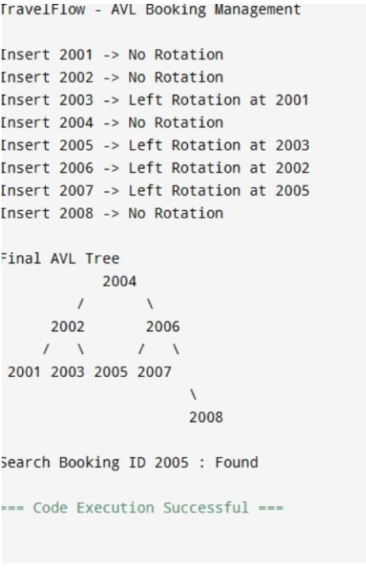

• AVL Tree maintained balanced structure.
• Search operations remained efficient.
• Document retrieval performance improved significantly.
• Suitable for document indexing applications.

GitHub Link: https://github.com/krishnavamshiyadavmuntha0826/DSA

